AGU's Social Media Policy

The following are the rules and social media principles to be observed while commenting, sharing, or liking content via the University's social media accounts:

1. On the University's social media accounts, never share, like, and comment on political matters. Likewise, do not repost or like political content shared by another institution or person on their own social media accounts.
2. Considering international instructors and students of the University, use two languages (Turkish and English) when posting some of the contents on its social media accounts. Also, use plain and simple language.
3. Avoid tarnishing the University's reputation in your posted comments. Also, refrain from using a judgmental and negative tone.
4. Do not criticize the operational policy of the University via the institutional social media accounts.
5. Do not share private information about the institution, such as projects and presentations, on social media.
6. Do not make promises that you cannot keep.
7. Avoid statements, comments, shares, and likes which could damage personal rights and be discriminatory, racist, separatist, provocative, violent, or obscene.
8. Make sure that the images you share do not violate any copyright.
9. Do not deform, change, or use differently the University logo on any webpage you created.
10. In your designs, align the logo to the left and the office, faculty, or department title to the right; use Penumbra Regular font and 18-point type. Highlight the abbreviation AGU when using the University's logo and name. Never change the colors of the logo.

Sample: 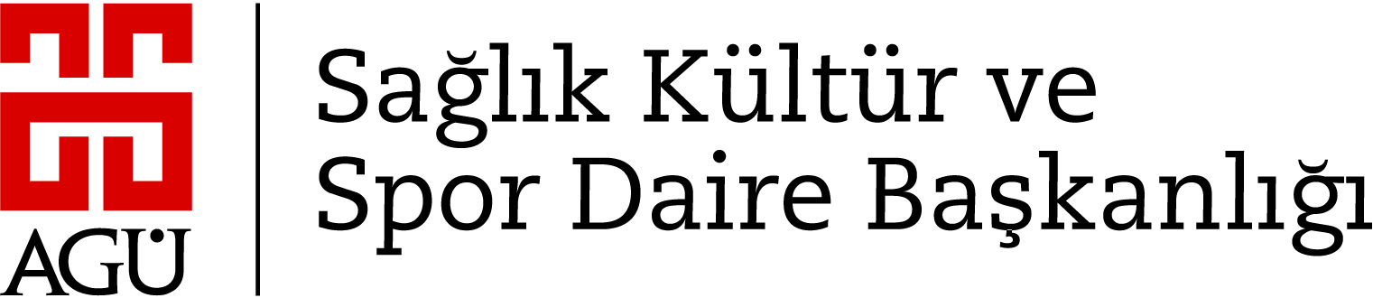

1. While following or liking other social media users or institutional accounts, be mindful and check if their profiles are suitable for the University's mission and vision.